**CATHOLIC CHURCH NORTHERN DIOCESES**

**Guidance on Creating an NI Direct Account & Processing an**

**AccessNI ONLINE Application**

|  |
| --- |
| Before processing your AccessNI ONLINE Application, please ensure you have the following information at hand:   * National Insurance Number (if applicable) * Valid/current Driving Licence (if applicable) * Valid/current Passport (if applicable) * Make sure you know a 5-year address history, including POST CODE. If you are unsure about previous address post codes, you can look these up on the internet. * **The Catholic Church Northern Diocese PIN NUMBER (480892)** you will be asked to enter this number after logging into the AccessNI Application Website. * Please be advised: Your AccessNI application will be deleted after 3 months, if not progressed |

**HOW TO SET UP, ACTIVATE AND SIGN INTO YOUR ACCESSNI ACCOUNT**

|  |  |
| --- | --- |
| 1 | Go to the nidirect.gov.uk website. You can do this by following the link below:  [https://www.nidirect.gov.uk](https://www.nidirect.gov.uk/information-and-services/accessni-criminal-record-checks/apply-accessni-check)/accessni-applications |

|  |  |
| --- | --- |
| 2 | On the ‘AccessNI: Criminal record checks’ section, click on:  ‘Apply online for an **ENHANCED CHECK** through a registered body’, shown below      This one  Please note: the Catholic Church **does not process Basic or Standard AccessNI** checks |
| 3 | Now you need to create and activate an AccessNI account on the NI Direct portal in order to process an Enhanced Disclosure check – to do this follow these steps:  **Step 1 – Create or Log in to your account**  Scroll down the screen until you see this text box/link, then click on it:  You will be taken to this screen. You will need to choose ‘Create Account’ (If you do not already have an NI Direct Account) – under ‘I need an account’ section. |

You will be required to complete the ‘Create an account on nidirect’ screen in full.

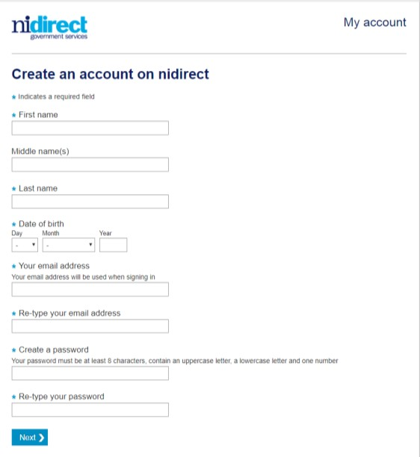

NOTE: Please make a note of your password. You will need it later.

You must click ‘Next’ and you will be taken to the screen below where you must enter your contact details and make your declaration.

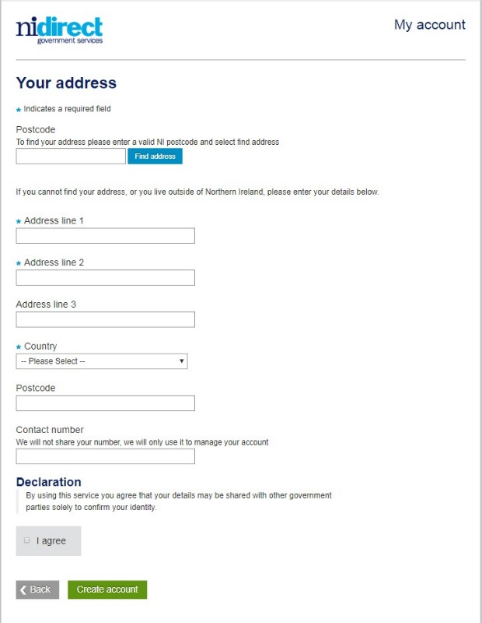

Once you have completed these boxes, click the ‘Create Account’ button and the following screen message will appear:

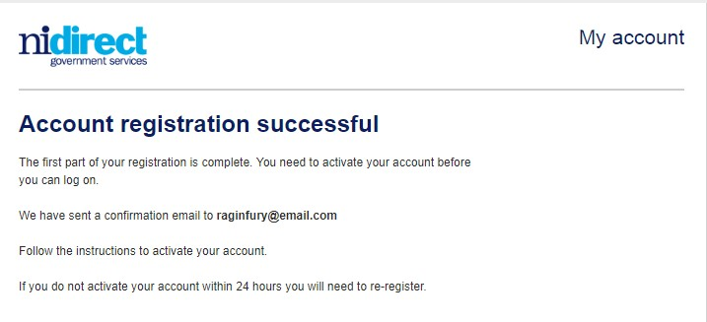

**Close the website**

# Step 2 – Activate your account

Log into your email account that you used for the AccessNI Registration, where you will find a new email from AccessNI within 5-10 minutes of creating your account. The content of your email is as follows:

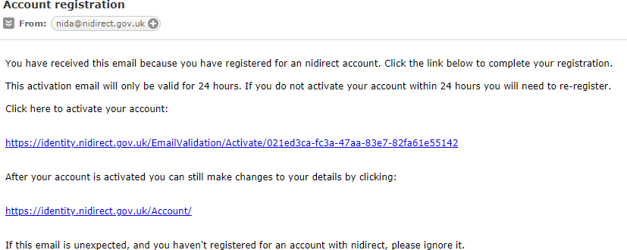

(If you **do not get an email from AccessNI**, contact them on 0300 200 7888).

Follow the instructions in the email to activate your account.

When your account has been successfully activated, you will see this screen.

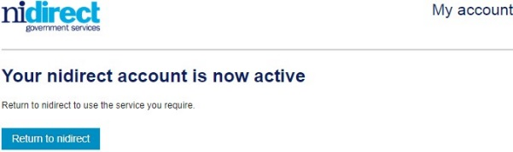

# Step 3 – Log into your AccessNI Account

You can click on the ‘Return to nidirect’ button to return to the nidirect website to commence using the AccessNI on-line services. You will need to make your way back to this screen so you can sign into your account.

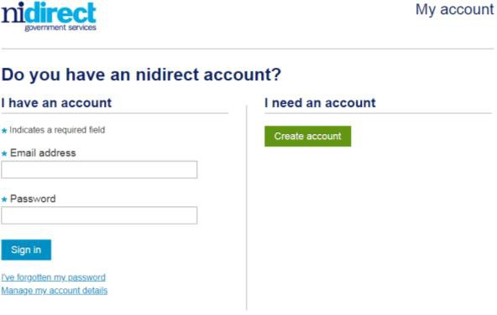

You will need the following information to get started on the application for an enhanced disclosure check:

* Your email address
* Your password (the one you have written down earlier)

After you have signed in you must:

* **Enter PIN code (480892)**
* Press Next
* You are now at STEP 3 of the online application process

It is important to note: **When you reach the “Organisation reference” box**

**at STEP 3 of the AccessNI online application, please type in your Diocese** (eg Down and Connor, Armagh, Derry, Dromore, Clogher or Kilmore) into the box as indicated below:

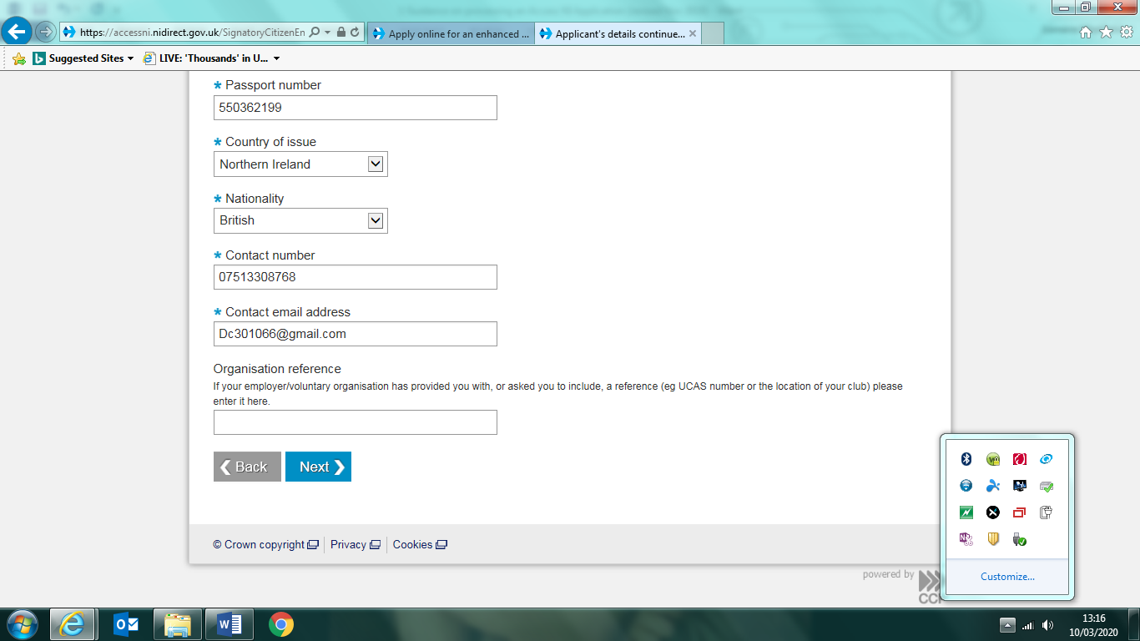

**Type in your Diocese** (eg Down and Connor, Armagh, Derry, Dromore, Clogher or Kilmore) into this box

Continue to end and submit application

Your online application will be matched with your Identity Verification Form and Confidential Declaration Form by the Vetting Staff and further processed to AccessNI.