What is Safeguarding?

the term **safeguarding** is intended to be used in its widest sense, encompassing the full range of promotion, prevention and protection activity.

**Effective safeguarding activity will:**

• **Promote** the welfare for the child and young person;

• **Prevent** harm occurring through early identification of risk and appropriate, timely

intervention; and

• **Protect** children and young people from harm when this is required.

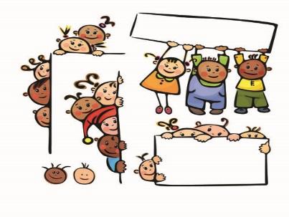

What is Harm?

**What is Child Protection**

Child **protection** refers specifically to the activity that is undertaken to protect individual children or young people who are suffering or are likely to suffer significant harm.

A child in need of protection is a child who is at risk of, or likely to suffer, significant harm which can be attributed to a person or persons or organisation, either by an act

of commission or omission.

Harm can be suffered by a child or young

person by acts of abuse perpetrated upon

them by others. Abuse can happen in any family, but children may be more at risk if

their parents have problems with drugs, alcohol and mental health, or if they live in a

home where domestic abuse happens. Abuse can also occur outside of the family

environment. Babies and children with disabilities can also be more vulnerable to

suffering abuse.

Types of Abuse/ Harm can be caused by:

• Physical abuse;

• Sexual abuse;

• Emotional abuse;

• Neglect; and

• Exploitation.

**Physical Abuse** is deliberately physically hurting a child. It might take a variety of

different forms, including hitting, biting, pinching, shaking, throwing, poisoning,

burning or scalding, drowning or suffocating a child.

**Sexual Abuse** occurs when others use and exploit children sexually for their own

gratification or gain, or the gratification of others. Sexual abuse may involve physical

contact or it may include non‐contact activities. Examples of these include, involving children in the production of sexual images, forcing children to look at sexual images or watch sexual activities, encouraging children to behave in sexually inappropriate ways or

grooming a child in preparation for abuse (including via e‐technology). Sexual abuse

is not solely perpetrated by adult males. Women can commit acts of sexual abuse, as

can other children.

**Emotional Abuse** is the persistent emotional maltreatment of a child. It is also sometimes called psychological abuse and it can have severe and persistent adverse effects on a child’s emotional development. Emotional abuse may involve deliberately telling a child that they are worthless, or unloved and inadequate. It may include not giving a child opportunities to express their views, deliberately silencing them, or ‘making fun’ of what they say or how they communicate. Emotional abuse may involve bullying –including online bullying through social networks, online games or mobile phones – by a child’s peers.

**Neglect** is the failure to provide for a child’s basic needs, whether it be adequate

food, clothing, hygiene, supervision or shelter that is likely to result in the serious

impairment of a child’s health or development. Children who are neglected often

also suffer from other types of abuse.

**Exploitation** is the intentional ill‐treatment, manipulation or abuse of power and control over a child or young person; to take selfish or unfair advantage of a child or young person or situation, for personal gain. It may manifest itself in many forms such as child labour, slavery, servitude, engagement in criminal activity, begging, benefit or other financial fraud or child trafficking. Exploitation can be sexual in nature.

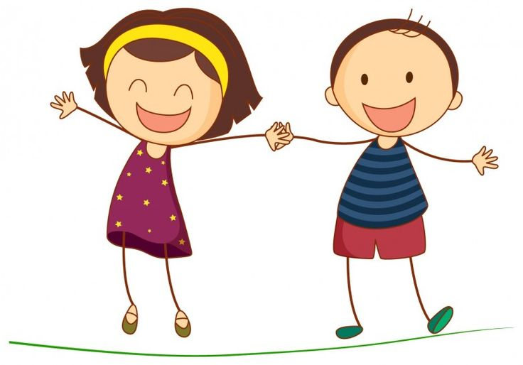

**How to respond if you have a concern**

**DO**

* Take the child seriously
* Tell the child they have done the

right thing by telling you

* Clarify if necessary
* Make an accurate record as soon as

possible

* Inform the designated person without delay

**DON’T**

* Promise confidentiality
* Investigate
* Ask leading questions
* Repeatedly question/ask the child

to repeat the disclosure over and over

Reporting a Concern

If you are concerned that a child or young person you know is at risk, or you wish to raise a matter from the past, you are invited to contact any of the following:

Dromore Designated Person: Patricia Carville – 07789917741

NSPCC Helpline – 0808 800 5000

N.I. Childline – 0800 1111

Southern Health and Social Care Trust

Access Service – 0800 783 7745

South Eastern Health and Social Care Trust

Access Service – 0300 1000 300

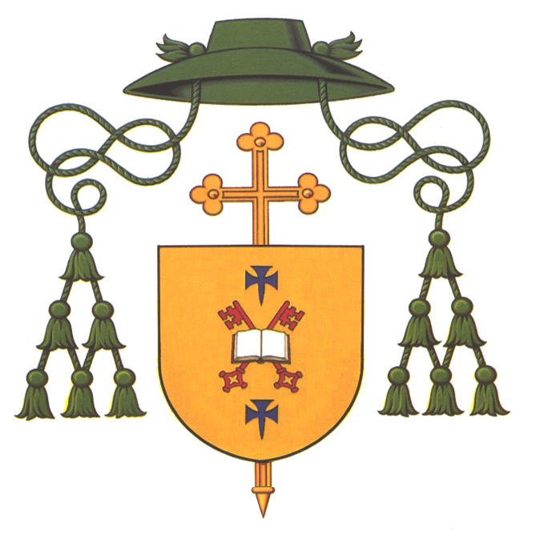

Diocese of Dromore

Safeguarding Children