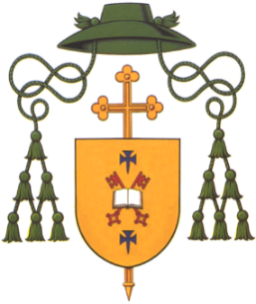
DIOCESE OF DROMORE
Most Rev Eamon Martin DD
Apostolic Administrator
Bishop’s House
44 Armagh Road
Newry BT35 6PN
Co. Down

Tel: (028) 3026 2444

EMBARGOED – Noon, Wed 28 Sept 2021

Press Release on Dromore Redress Scheme

The Diocese of Dromore apologise unreservedly for the hurt and damage caused to victims and survivors of any priest or church representative acting under its authority. The Diocese of Dromore finds such behaviour towards children and vulnerable people abhorrent, inexcusable, and indefensible.

The Diocese of Dromore is initiating a Redress Scheme for victims of sexual abuse by priests in the diocese. The Diocese is committed to doing what it can to help bring healing to the survivors of clerical sexual abuse, and to all those affected by these egregious crimes.

Having met with a number of survivors and having examined the various existing legal claims against the diocese, Archbishop Eamon Martin wishes to facilitate a resolution process to enable the provision of financial and other supports for survivors without undue further delay.

This Redress Scheme will be open to victims and survivors of child sexual abuse suffered at the hands of representatives of the Diocese. It endeavours to ensure a process which is victim-centered and aims to provide victims with recognition and reasonable compensation without the need for lengthy investigation and litigation.

The Diocese understands that redress may take varying forms. As well as enabling the provision of financial redress, the Scheme includes the possibility of a personal apology on behalf of the Diocese and other ways of providing pastoral support. The Diocese will also support the provision of counselling via the Towards Healing service.

The Diocese is willing to commit whatever resources it has available for the purpose of redress to this scheme, even if that should exhaust those resources.

The Scheme will respond to applications where there are allegations of sexual abuse (including sexual grooming), which may or may not have been accompanied by physical and/or emotional abuse, and which occurred when the Applicant was under the age of 18. All applications will be assessed by an independent Panel, appointed via an independent process managed by a third-party organisation. In assessing applications, the Panel will have regard to all the available information and make its decision on the balance of probabilities and on a majority basis. The process will fall outside the civil litigation process and be comparable to a mediation. It is anticipated that the process will be informal in nature but is intended to be binding on the parties should a resolution be agreed.

Archbishop Eamon Martin is also committed to continuing his ongoing pastoral outreach to survivors, making himself available to meet with those victims who wish to share their story with him and to consider with him other ways in which their pain can be acknowledged and by which their healing can be assisted.

ENDS

