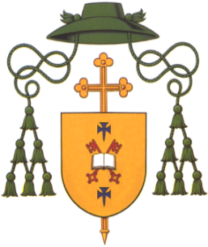
DIOCESE OF DROMORE
Most Rev Eamon Martin DD
Apostolic Administrator
Bishop’s House
44 Armagh Road
Newry BT35 6PN
Co. Down

Tel: (028) 3026 2444

Extension of the Dromore Diocesan Redress Scheme (14th July 2023)

The Diocese of Dromore has decided to extend its Redress Scheme for victims of sexual abuse for a further six months.
On 29th September 2021 the Diocese of Dromore established a redress scheme for victims of sexual abuse perpetrated by members of the clergy who were under its authority. The Scheme aimed to provide a more straightforward and quicker process by which awards to compensate for abuse could be provided as opposed to what is sometimes described as the lengthy, costly and adversarial route of litigation.
In the 21 months since it was established over 25 applicants have applied to the Scheme. To date over 90% have had their applications considered by an independent panel, such initial assessment on average being 33 days after the application was received. Over 90% of applicants have accepted the panel awards offered.
Awards have been made which cross the full range of the scheme. Where applicants have been legally represented their solicitors have also been paid their costs in accordance with the terms of the scheme (including where applicable costs incurred in prior litigation.)
The speed with which the scheme responds to the majority of applications acknowledges the criticism often raised by victims and survivors of abuse that the civil claims process is too slow.
The Diocese continues to listen to the voices of victims and survivors and to also have regard to actions being taken in other jurisdictions to respond to those who have been abused. In addition to the financial support all applicants to the Scheme are invited to access pastoral support should they wish to receive the same, as well as to request to meet with Archbishop Eamon Martin and to seek support for counselling from Towards Healing Counselling & Support Service.
Conscious that remaining diocesan funds are limited, the Diocese is keen to ensure that all those who were abused have the opportunity to receive some redress whilst funds are available.
To enable all those who were abused to apply to the Scheme the Diocese has extended the Scheme by 6 months enabling others to make applications up to 29th March 2024.
Any individual who suffered sexual abuse when they were under age 18 which was perpetrated by someone for whom the Diocese is vicariously liable, can apply to the Scheme. More details can be found at https://www.dromoreredress.org/.
Statement Ends

